The searchable area is a 5x5 grid of Minecraft cubes. The goal is to get from the bottom left dirt block to the top right dirt block, avoiding the raised walls (they’re impassable). Pressing the enter key will start the search.

I wasn’t able to get the results to print to the UI, but I was able to get them to show in the console.

The program runs like this:

* Program starts, UI/entities draw, AStar initial values are set.
* Program does nothing until ‘enter’ is pressed.
* AStar RunSearch() method is called, which searches for the best path to the goal.
* The == operator overload is called whenever two NODEs are compared.
* Once the goal has been reached, the RunSearch() method exits, and sets upOrRight to the proper value, which should always be true (program comments explains more)

The console prints the steps in the found path multiple times, but it still prints the shortest path. Everything with A\*’s functionality works properly.

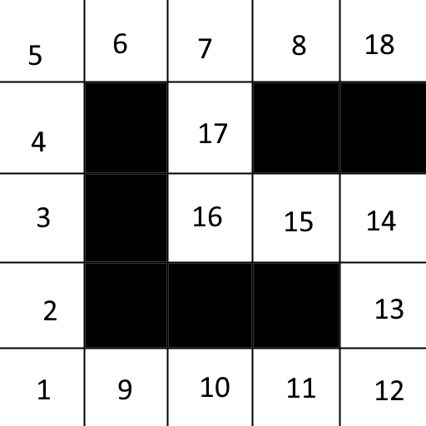

Map showing the node/block locations as they’re visually seen. Walls are solid black.